**01.FOOTBALL**

**Short term**

* Ankle sprains**: [cricket,volleyball,tennis]**
* **Rest**: Immediately stop playing and rest your ankle to prevent further injury.
* **Ice**: Apply ice to the injured area for 15-20 minutes every few hours during the first 48 hours after injury. This helps reduce swelling and pain.
* **Compression**: Use an elastic bandage or compression wrap around the ankle to help control swelling.
* **Elevation**: Keep your ankle elevated above heart level as much as possible, especially during the first 48 hours.
* **Pain Relief**: pain relievers like ibuprofen or acetaminophen can help reduce pain and inflammation. Follow dosage instructions.
* **Avoid Heat**: Do not use heat on the injury initially, as it can increase swelling.
* **Supportive Devices**: Consider using ankle braces or supports during recovery and when returning to play to provide extra stability.
* **Professional Evaluation**: If you suspect a severe injury like a fracture or if the pain and swelling are severe, consult a healthcare professional for a thorough evaluation.

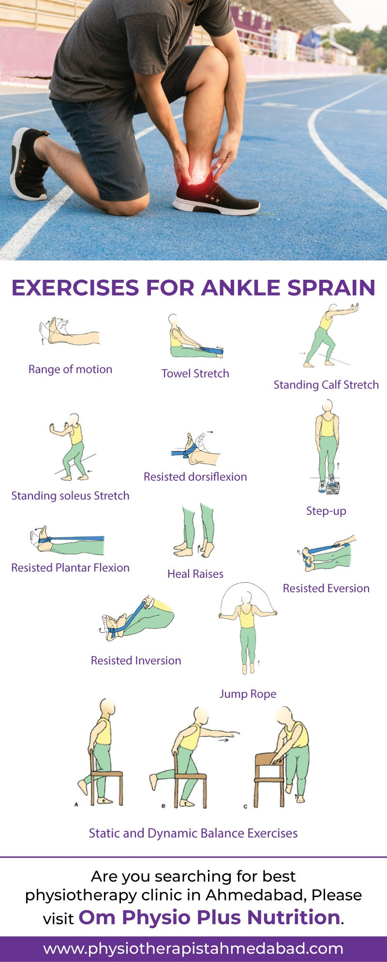

* Hamstring Strains:
* **Rest and Avoid Further Strain**: Give your hamstring adequate time to heal by resting it. Avoid activities that could aggravate the strain, such as running, jumping, or heavy lifting.
* **Ice Therapy**: Apply ice packs to the affected area for 15-20 minutes every few hours during the initial 48 hours after injury. This helps reduce swelling and numbs the pain.
* **Compression**: Use an elastic compression bandage or wrap around the thigh to help reduce swelling and provide support to the injured muscle.
* **Elevation**: When resting, elevate your leg by propping it up on pillows. This can also help reduce swelling.
* **Pain Relief Medication**: Over-the-counter pain relievers like ibuprofen or acetaminophen can help manage pain and reduce inflammation.
* **Heat Therapy**: After the initial 48 hours, you can use heat packs or take warm baths to help relax and loosen the muscle. Heat can improve blood circulation to the injured area.
* **Massage Therapy**: Gentle massage around the injured area may help reduce muscle tension and promote blood flow, aiding in healing.
* **Use of Supportive Devices**: Consider using a cane or crutches if needed to avoid putting weight on the injured leg, especially during the initial recovery phase.
* **Physical Therapy**: A physical therapist can design a specific rehabilitation program tailored to your injury, helping you regain strength, flexibility, and function in your hamstring.

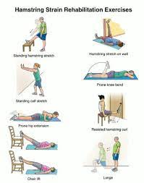

* Groin Strains: [Hockey, baseball, hockey, ]
* **Rest**: Give your groin muscles time to heal by avoiding activities that aggravate the strain, such as running, jumping, or sudden movements that strain the groin area.
* **Ice Therapy**: Apply ice packs to the affected groin area for 15-20 minutes every few hours during the first 48 hours after the injury.
* **Compression**: Use an elastic compression bandage or wrap around the groin area to provide support and reduce swelling.
* **Elevation**: When resting, try to elevate your leg by propping it up on pillows. This can help reduce swelling and promote blood flow to the area.
* **Pain Relief Medication**: Over-the-counter pain relievers like ibuprofen (Advil, Motrin) or acetaminophen (Tylenol) can help manage pain and reduce inflammation.
* **Heat Therapy**: After the first 48 hours, you can use heat packs or take warm baths to help relax the muscles and improve blood circulation.
* **Gentle Stretching**: Once the acute pain subsides, start gentle stretching exercises for the groin muscles to improve flexibility and prevent stiffness.
* **Physical Therapy**: Consult with a physical therapist for a customized rehabilitation program. Physical therapy can help strengthen the groin muscles, improve range of motion, and prevent future injuries.
* 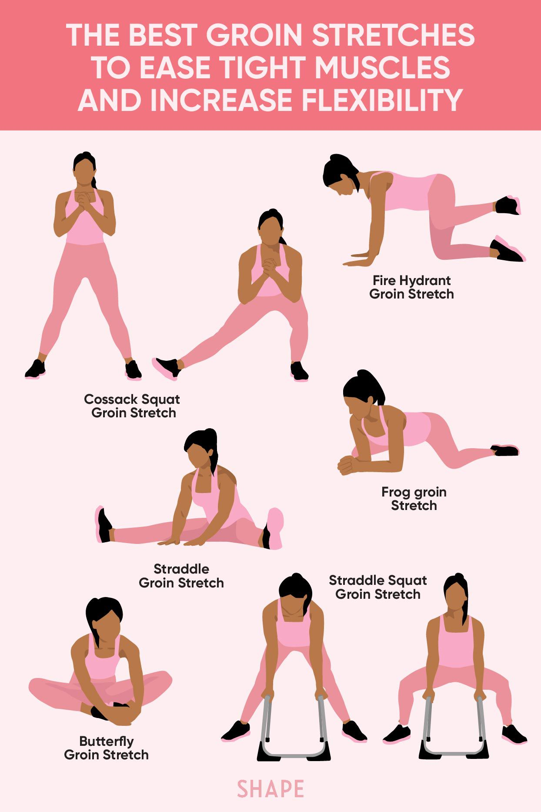Muscle Spasms:
* **Rest**: Give the strained muscle adequate time to heal by resting it. Avoid activities that could further strain or aggravate the muscle.
* **Ice Therapy**: Apply ice to the affected area for 15-20 minutes every few hours during the first 48 hours after the injury.
* **Compression**: Use an elastic compression bandage or wrap around the strained muscle to help reduce swelling and provide support.
* **Elevation**: When resting, elevate the injured muscle above the level of your heart if possible. This can also help reduce swelling and promote drainage of excess fluid.
* **Pain Relief Medication**: Over-the-counter nonsteroidal anti-inflammatory drugs (NSAIDs) like ibuprofen (Advil, Motrin) or acetaminophen (Tylenol) can help relieve pain and reduce inflammation.
* **Heat Therapy (After 48 Hours)**: Once the initial swelling has gone down (after 48 hours), you can use heat packs, warm baths, or heating pads to relax the muscles and improve blood flow.
* **Gentle Stretching**: After the acute pain has subsided, gently stretch the strained muscle to improve flexibility and prevent stiffness
* **Massage Therapy**: Gentle massage around the strained muscle can help promote blood flow, reduce muscle tension, and alleviate pain.
* **Hydration and Nutrition**: Drink plenty of water to stay hydrated, which supports overall muscle health and healing. Ensure you're getting a balanced diet rich in nutrients like protein, vitamins, and minerals to support muscle repair.
* **Physical Therapy**: Consider consulting a physical therapist for a tailored rehabilitation program. A therapist can guide you through specific exercises to strengthen the injured muscle, improve range of motion, and prevent future injuries.

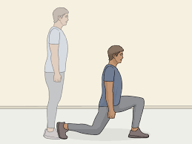

* Wrist and elbow injuries: [tennis,]
* **Rest and Immobilization**: Avoid activities that strain the wrist and consider using a wrist splint or brace to immobilize the joint and prevent further injury.
* **Ice Therapy**: Apply ice packs to the affected wrist for 15-20 minutes every few hours to reduce pain and inflammation. Do not apply ice directly to the skin; use a cloth or towel as a barrier.
* **Compression**: Wrap the wrist with an elastic bandage to provide support and help reduce swelling.
* **Elevation**: When resting, keep the wrist elevated above the level of your heart to reduce swelling and promote fluid drainage.
* **Pain Relief Medication**: Over-the-counter pain relievers like ibuprofen (Advil, Motrin) or acetaminophen (Tylenol) can help manage pain and inflammation.
* **Avoiding Impact Activities**: Refrain from activities that put strain on the wrist, such as heavy lifting or pushing with the affected hand.

**Elbow Injuries (e.g., Tennis Elbow, Elbow Strain):**

* **Rest**: Rest the injured elbow and avoid activities that exacerbate the pain.
* **Ice Therapy**: Apply ice packs to the affected elbow for 15-20 minutes every few hours to reduce pain and swelling.
* **Compression**: Use an elbow brace or wrap to provide support and stabilize the joint.
* **Elevation**: Keep the elbow elevated to reduce swelling and promote healing.
* **Pain Relief Medication**: Take over-the-counter pain relievers as directed to manage pain and inflammation.
* **Avoiding Overuse**: Modify activities or techniques that may have caused the injury, especially in sports like football that involve repetitive arm motions.
* **Proper Equipment**: Ensure that football gear, such as pads and braces, are properly fitted to provide adequate protection and support for the elbows and wrists.

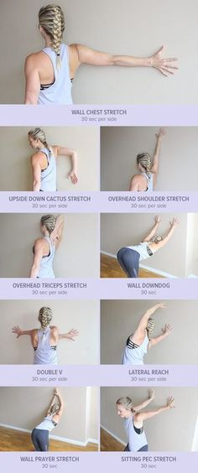

* Head concussions: [baseball, ]

### Initial Remedies:

* **Rest**: Encourage the player to rest physically and mentally. This includes avoiding physical activities, screen time (TV, computer, phone), and mentally taxing tasks.
* **Ice Pack**: If there is any swelling or discomfort, applying an ice pack to the head can help reduce pain and inflammation. Use caution to prevent frostbite;

### Medical Evaluation and Management:

* **Medical Evaluation**: Follow the advice of healthcare professionals regarding further evaluation. This may involve neurological assessments, cognitive tests, and imaging studies (like CT scan or MRI) to rule out more serious injuries.
* **Rest and Gradual Return to Activity**: The player should refrain from sports and physical activities until cleared by a healthcare provider.

### Long-Term Care and Prevention:

* **Follow Medical Recommendations**: Adhere to the treatment plan outlined by healthcare professionals. This may include rest, gradual return to activity, and specific guidelines for concussion recovery.
* **Education and Prevention**: Educate athletes, coaches, and parents about the signs and symptoms of concussion. Emphasize the importance of reporting symptoms and following concussion protocols.
* **Proper Equipment and Techniques**: Ensure that players wear appropriate protective gear, including helmets designed to reduce the risk of head injuries.
* **Monitoring for Symptoms**: Continuously monitor the player for any recurring symptoms of concussion, even after returning to play.

**LONG TERM**

* Knee injuries: [golf, ]
* **Seek Medical Evaluation**: Consult with a sports medicine physician or orthopedic specialist for a proper diagnosis and treatment plan tailored to your specific injury.
* **Physical Therapy**: If recommended by your healthcare provider, participate in physical therapy sessions to strengthen the muscles around the knee, improve flexibility, and restore function.
* **Pain Relief Medication**: Over-the-counter nonsteroidal anti-inflammatory drugs (NSAIDs) such as ibuprofen (Advil, Motrin) or acetaminophen (Tylenol) can help reduce pain and inflammation.
* **Bracing or Support**: Depending on the type and severity of the injury, wearing a knee brace or using supportive devices may be beneficial to stabilize the knee and prevent further damage.
* 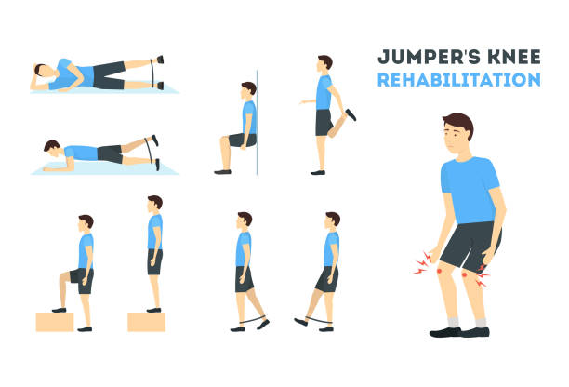**Heat Therapy (after 48 hours)**: Once the initial swelling has decreased, heat therapy (warm compress, warm bath) can help relax muscles and improve blood flow to the injured area, promoting healing.
* Meniscus tears:
* **Non-Surgical Treatment**:
  + **Physical Therapy**: A physical therapist can design a rehabilitation program to strengthen surrounding muscles and improve knee stability.
  + **Bracing**: Depending on the type and severity of the tear, wearing a knee brace may provide support and alleviate symptoms.
  + **Medications**: Over-the-counter pain relievers (e.g., ibuprofen, acetaminophen) can help manage pain and inflammation.
* **Surgical Treatment** (for severe tears or persistent symptoms):
  + **Arthroscopic Surgery**: Minimally invasive surgery to repair or trim the torn meniscus.
  + **Meniscus Repair**: In some cases, the meniscus can be repaired surgically to preserve knee function.
  + **Meniscectomy**: Surgical removal of the damaged part of the meniscus may be necessary if repair is not possible.
* Bone fractures:
* **Medical Evaluation**:
  + Receive a thorough evaluation by a healthcare professional, which may include physical examination and imaging tests (e.g., X-rays, CT scans) to determine the type and severity of the fracture.
* **Immobilization with Cast or Splint**:
  + If the fracture requires stabilization, the injured limb may be placed in a cast or splint to keep the bones aligned and promote healing.
* **Pain Management**:
  + Over-the-counter pain relievers (e.g., acetaminophen, ibuprofen) may be recommended to manage pain and discomfort.
* **Surgical Intervention** (if necessary):
  + In some cases, surgery may be required to realign the bones and secure them with pins, plates, or screws.
* Achilles tendinitis: [tennis,]
* **Medical Evaluation**:
  + Consult with a healthcare professional, such as a sports medicine physician or orthopedic specialist, for a proper diagnosis and treatment plan.
* **Orthotics or Supportive Shoes**:
  + Wear supportive footwear or orthotic inserts to provide cushioning and reduce stress on the Achilles tendon during activities.
* **Calf Muscle Stretching**:
  + Perform gentle stretching exercises for the calf muscles to alleviate tightness and reduce tension on the Achilles tendon.
* **Eccentric Strengthening Exercises**:
  + Eccentric exercises, such as heel drops, can help strengthen the Achilles tendon and promote healing. These exercises involve lowering the heel below the level of the step or platform.
* **Cross-Training**:
  + Engage in low-impact activities like swimming or cycling to maintain cardiovascular fitness without aggravating the Achilles tendon.
* **Pain Relief Medication**:
  + Over-the-counter nonsteroidal anti-inflammatory drugs (NSAIDs), such as ibuprofen or naproxen, can help reduce pain and inflammation.
* ACL tears: (anterior cruciate ligament) **[volleyball, baseball]**
* **Surgical Intervention**:
  + Many ACL tears require surgical reconstruction to restore knee stability and function. The surgeon will replace the torn ACL with a graft (tissue from another part of your body or a donor) through arthroscopic surgery.
* **Rehabilitation and Physical Therapy**:
  + After surgery, participate in a structured rehabilitation program led by a physical therapist to restore knee strength, range of motion, and stability.
  + Physical therapy will include exercises to strengthen the quadriceps, hamstrings, and other muscles around the knee.

**02. CRICKET**

Short term

* Shoulder sprains: [volleyball]
* **Medical Evaluation**:
  + Consult with a sports medicine physician or orthopedic specialist for a proper diagnosis and treatment plan.
* **Pain Relief Medication**:
  + Over-the-counter pain relievers like ibuprofen or acetaminophen can help manage pain and reduce inflammation.
* **Physical Therapy**:
  + A physical therapist can design a rehabilitation program focusing on shoulder strengthening and flexibility exercises.
* **Range of Motion Exercises**:
  + Perform gentle range of motion exercises to maintain flexibility and prevent stiffness in the shoulder joint.
* **Avoid Overhead Activities**:
  + Temporarily avoid activities that involve overhead movements (e.g., bowling) until the shoulder has healed sufficiently.

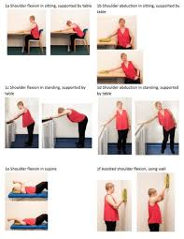

* Elbow sprains:
* **Pain Relief Medication**:
  + Over-the-counter pain relievers like ibuprofen or acetaminophen can help manage pain and reduce inflammation.
* **Physical Therapy**:
  + A physical therapist can design a rehabilitation program focusing on strengthening and flexibility exercises for the elbow.
* **Elbow Brace or Splint**:
  + Depending on the severity of the sprain, wearing an elbow brace or splint may provide support and stability during activities.
* **Modify Cricket Activities**:
  + Temporarily avoid activities that exacerbate elbow pain, such as aggressive bowling or batting, until the elbow has healed sufficiently.
* **Gentle Stretching**:
  + Perform gentle stretching exercises for the forearm muscles and elbow joint to improve flexibility and reduce stiffness.
* Rib sprains:
* **Medical Evaluation**:
  + It's important to consult with a healthcare professional, such as a sports medicine physician or orthopedic specialist, to confirm the diagnosis and rule out more serious injuries like rib fractures.
* **Physical Therapy**:
  + If recommended by your healthcare provider, engage in physical therapy sessions to learn exercises that can promote rib healing and improve flexibility.
* **Gentle Stretching**:
  + Perform gentle stretching and breathing exercises to maintain rib mobility and prevent stiffness.
* **Heat Therapy (after initial inflammation subsides)**:
  + Use heat packs or warm compresses on the affected area to promote blood flow and relaxation of muscles.

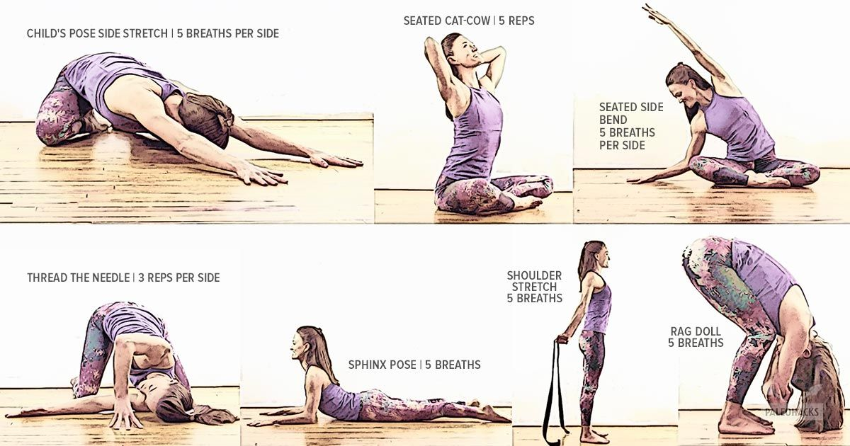

* Joint sprains:
* **Medical Evaluation**:
  + Consult with a healthcare professional, such as a sports medicine physician or orthopedic specialist, for a proper diagnosis and treatment plan.
* **Physical Therapy**:
  + Participate in physical therapy sessions to learn exercises that can improve joint stability, flexibility, and strength.
* **Joint Splinting or Bracing**:
  + Depending on the severity of the sprain, using a splint or brace may provide support and facilitate healing of the joint.
* **Gentle Range of Motion Exercises**:
  + Once pain begins to subside, perform gentle range of motion exercises to maintain flexibility and prevent stiffness in the joint.
* **Heat Therapy (after initial inflammation subsides)**:
  + Use heat packs or warm compresses on the affected joint to promote blood flow and relaxation of muscles.
* Lower back pain: [volleyball, golf, tennis]
* **Medical Evaluation**:
  + Consult with a healthcare professional, such as a sports medicine physician or physiotherapist, for a proper diagnosis and treatment plan.
* **Physical Therapy**:
  + Participate in physical therapy sessions to learn specific exercises and techniques to strengthen the core muscles, improve posture, and reduce lower back strain.
* **Heat Therapy**:
  + Apply heat packs or warm compresses to the lower back after the initial inflammation has subsided to promote blood flow and muscle relaxation.
* **Posture Correction**:
  + Work on maintaining proper posture during cricket activities, including batting, fielding, and bowling, to reduce strain on the lower back.
* **Core Strengthening**:
  + Strengthen the core muscles (abdominals, obliques, and lower back muscles) through targeted exercises to provide better support and stability for the spine.
* **Modify Cricket Techniques**:
  + Work with a coach to refine cricket techniques and movements to minimize stress on the lower back.
* **Maintain Overall Fitness**:
  + Engage in regular cardiovascular exercise and strength training to maintain overall fitness and prevent muscle imbalances that can contribute to lower back pain.

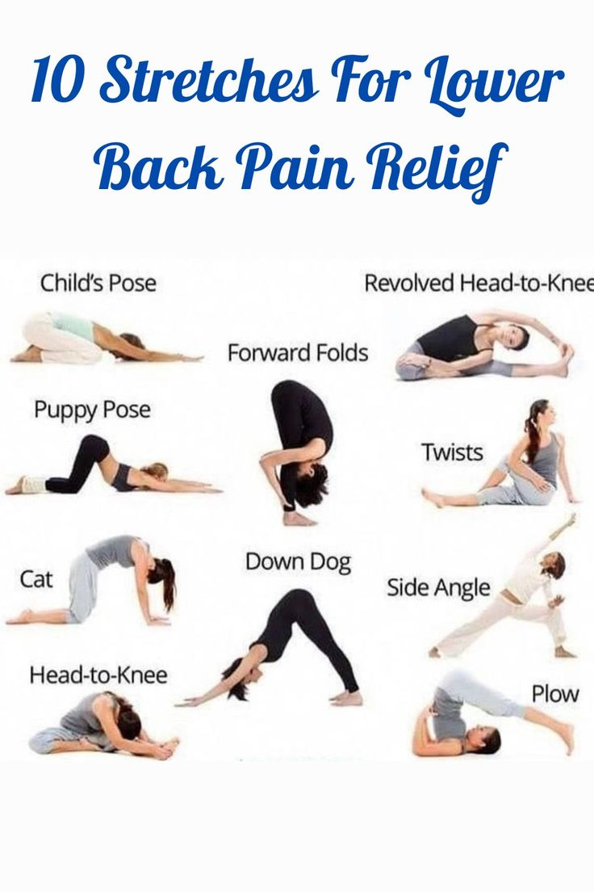

* **Scraps, wounds and bruises:**

**Scraps and Wounds:**

* **Cleaning the Wound**:
  + Rinse the affected area with clean water to remove dirt and debris. Use a mild soap if available.
* **Antiseptic Application**:
  + Apply an antiseptic solution or wipe (e.g., hydrogen peroxide, iodine) to disinfect the wound and prevent infection.
* **Bandaging**:
  + Cover the wound with a sterile bandage or adhesive strip to protect it from further contamination and promote healing.
* **Pain Relief**:
  + Take over-the-counter pain relievers like acetaminophen or ibuprofen to alleviate pain and discomfort.
* **Change Dressings**:
  + Regularly change the bandage and clean the wound to prevent infection and promote healing.

**Bruises:**

* **Rest and Ice Therapy**:
  + Apply ice packs to the bruised area for 15-20 minutes every few hours during the first 24-48 hours to reduce swelling and pain.
* **Compression**:
  + Use a compression bandage or wrap around the bruised area to minimize swelling and provide support.
* **Elevation**:
  + Elevate the affected limb above heart level when resting to further reduce swelling.
* **Pain Management**:
  + Take over-the-counter pain relievers to manage pain and discomfort associated with bruises.

**LONG TERM**

* Shoulder dislocation: [hockey, baseball, ]
* **Shoulder Reduction (Repositioning)**:
  + A healthcare professional will perform a shoulder reduction procedure to safely relocate the dislocated shoulder joint.
* **Pain Management**:
  + Pain relievers may be administered to manage pain and discomfort during and after the reduction procedure.
* **Imaging Tests**:
  + X-rays or other imaging tests may be performed to assess for associated fractures or soft tissue injuries.
* **Immobilization**:
  + After the shoulder is reduced, the arm may be immobilized with a sling or shoulder immobilizer to allow healing.
* **Physical Therapy**:
  + Once the acute phase has passed, physical therapy will be recommended to strengthen the shoulder muscles and improve range of motion.
* Lower limb injuries: Lower limb injuries are common in cricket due to the running, sprinting, and sudden directional changes involved in the sport.
* **Ice Therapy**:
  + Apply ice packs wrapped in a cloth to the injured area for 15-20 minutes every few hours to reduce pain and swelling.
* **Compression**:
  + Use an elastic bandage or compression wrap to stabilize the injured limb and reduce swelling.
* **Elevation**:
  + Elevate the injured limb above heart level when resting to further reduce swelling.
* **Pain Relief**:
  + Take over-the-counter pain relievers like ibuprofen or acetaminophen to manage pain and inflammation.
* **Bracing or Splinting**:
  + Depending on the type and severity of the injury, your healthcare provider may recommend using a brace or splint to provide support and stability to the injured limb.
* **Heat Therapy (after inflammation subsides)**:
  + Use heat packs or warm compresses to promote blood flow and relax muscles once the initial swelling has reduced.

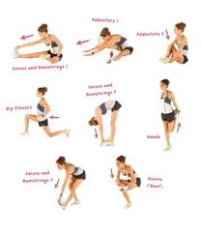

* Shin splits: Shin splints, also known as medial tibial stress syndrome, are a common overuse injury among cricket players, especially fast bowlers and runners.
* **Modify Activity**:
  + Temporarily decrease or modify cricket activities that contribute to shin splints, such as running on hard surfaces or excessive jumping.
* **Stretching and Strengthening**:
  + Perform gentle calf stretches and strengthening exercises for the lower leg muscles (calves, anterior tibialis) to improve flexibility and support.
* **Proper Footwear**:
  + Ensure that cricket shoes provide adequate cushioning and support, especially for players prone to shin splints.
* **Orthotics or Insoles**:
  + Consider using orthotic inserts or shock-absorbing insoles in cricket shoes to reduce impact on the shins.
* **Cross-Training**:
  + Engage in low-impact cross-training activities like swimming or cycling to maintain cardiovascular fitness without aggravating shin splints.
* Ligament pulls:
* **Compression and Elevation**: Use compression bandages to provide support and limit swelling. Elevate the injured limb above the level of the heart to further reduce swelling.
* **Pain Relief**: Over-the-counter pain relievers like ibuprofen or acetaminophen can help reduce pain and inflammation.
* **Avoid Putting Weight on the Injury**: If the ligament is in the leg or foot, avoid putting weight on it to prevent further damage. Crutches may be necessary for mobility.
* **Physiotherapy**: Once the acute phase of the injury has passed, a structured physiotherapy program is crucial. This will involve exercises to strengthen the affected area, improve range of motion, and promote healing.
* **Use Supportive Gear**: After recovery, consider using supportive gear like braces or taping to provide additional stability to the affected joint during play.
* **Proper Warm-up and Stretching**: Before returning to play, ensure thorough warm-up and stretching routines to reduce the risk of re-injury.

03. Volleyball

* Finger injuries: [golf,]
* **Pain Management**: Over-the-counter pain relievers like ibuprofen or acetaminophen can be used to manage pain and inflammation.
* **Buddy Taping**: If the injury is minor, buddy taping the injured finger to an adjacent finger can provide support and stability while allowing some mobility. Use adhesive tape to secure the fingers together, but avoid taping too tightly.
* **Avoid Stressful Activities**: Refrain from activities that could strain or stress the injured finger, such as gripping or lifting heavy objects.
* **Physical Therapy**: If the injury is severe or if there is a fracture, consult a healthcare professional such as a physiotherapist. They can recommend specific exercises to rehabilitate the finger and regain strength and mobility.

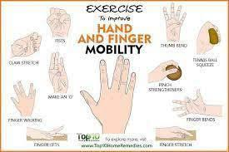

* Face and head concussions:
* **Medical Evaluation**: It's crucial to seek immediate medical evaluation from a healthcare professional, especially if the player experiences symptoms like dizziness, headache, confusion, nausea, or memory problems.
* **Physical and Cognitive Rest**: Following a concussion, both physical and cognitive rest are essential. This means avoiding activities that can strain the brain, such as reading, using screens (phone, computer), or playing sports.
* **Monitor Symptoms**: Keep a close watch on the player's symptoms and progress.
* **Pain Management**: Over-the-counter pain relievers like acetaminophen (Tylenol) can be used to manage headache or discomfort under medical
* **Avoid Physical Activity**: Refrain from any physical activity, including volleyball, until medically cleared by a healthcare professional
* **Protective Gear**: Consider using protective headgear or helmets designed for volleyball to reduce the risk of head injuries, especially during practices or games.

LONG TERM

* Finger ligament tears:

1. **Pain Management**: Over-the-counter pain relievers like ibuprofen or acetaminophen can help alleviate pain and reduce inflammation. Follow the recommended dosage instructions and consult with a healthcare professional if needed.
2. **Buddy Taping**: the injured finger to an adjacent finger for support and stability. Use adhesive tape to secure the fingers together, but avoid taping too tightly to prevent circulation problems.
3. **Avoid Stressful Activities**: Refrain from activities that strain the injured finger, such as gripping or lifting heavy objects.
4. **Seek Medical Evaluation**: It's important to consult a healthcare professional, such as a sports medicine doctor or orthopedic specialist, for a proper diagnosis and treatment plan. They may recommend imaging tests like X-rays or MRI to assess the extent of the ligament tear.
5. **Splinting or Immobilization**: Depending on the severity of the ligament tear, your healthcare provider may recommend splinting or immobilizing the finger with a finger splint or brace to protect the ligament and promote healing.
6. **Physical Therapy**:. A physiotherapist can provide specific exercises to regain strength, flexibility, and function in the injured finger.
7. **Protective Gear**: Consider using finger sleeves or protective tape during play to provide additional support and reduce the risk of re-injury once cleared to return to volleyball activities.

* Broken/dislocated bones:

1. **Medical Evaluation and Imaging**: Visit a healthcare professional, such as an orthopedic specialist or emergency physician, for a proper diagnosis. X-rays or other imaging tests may be necessary to assess the extent of the injury.
2. **Reduction (for Dislocations)**: If a joint is dislocated, it may need to be reduced (put back into place) by a trained medical professional.
3. **Rest and Rehabilitation**: Allow the bone to heal properly by resting and avoiding activities that can stress the injured area.
4. **Nutrition and Hydration**: Maintain a healthy diet rich in nutrients like calcium, vitamin D, and protein to support bone healing. Stay hydrated to facilitate recovery.
5. **Physical Therapy**: Depending on the severity of the injury, a physical therapist may prescribe exercises to restore range of motion, strength, and flexibility in the affected limb.
6. **Use Protective Gear**: Consider using protective gear, such as braces or padding, to prevent future injuries once cleared to return to volleyball.

* Patellar tendonitis (Jumper’s Knee): [tennis, ]
* **Pain Management**: Over-the-counter pain relievers such as ibuprofen or acetaminophen can help manage pain and reduce inflammation.
* **Stretching and Strengthening Exercises**: Perform gentle stretching and strengthening exercises for the quadriceps, hamstrings, and calves under the guidance of a physiotherapist. Strengthening the muscles around the knee can help alleviate stress on the patellar tendon.
* **Modify Activities**:Focus on low-impact exercises that do not strain the knees, such as swimming or stationary cycling.
* **Proper Footwear**: Ensure that you wear appropriate footwear with good shock absorption and support. Consider using orthotic inserts if recommended by a healthcare professional.
* **Cross-Training**: Engage in cross-training activities to maintain cardiovascular fitness and overall strength without stressing the knee joint excessively.
* **Patience and Persistence**: Recovery from patellar tendonitis can take time. Be patient with the rehabilitation process and avoid rushing back to full activity to prevent re-injury.
* Rotator cuff injuries: [tennis, golf]
* **Avoid Overhead Activities**: Refrain from activities that involve overhead motions, such as spiking or serving, until the shoulder pain subsides.
* **Stretching Exercises**: Perform gentle stretching exercises to maintain flexibility in the shoulder joint and surrounding muscles.
* **Shoulder Strengthening**: Gradually incorporate rotator cuff strengthening exercises into your rehabilitation program. These may include external and internal rotation exercises using resistance bands or light weights.
* **Posture Correction**: Address any postural issues that may contribute to shoulder pain. Poor posture can increase stress on the rotator cuff muscles and lead to further injury.
* **Modify Technique**: Work with a coach or trainer to modify volleyball techniques to reduce strain on the shoulders.
* **Cross-Training**: Engage in cross-training activities that do not aggravate the shoulder injury. Activities such as swimming or stationary cycling can help maintain cardiovascular fitness without stressing the shoulder joint.
* **Pain Management**: Over-the-counter nonsteroidal anti-inflammatory drugs (NSAIDs) like ibuprofen or acetaminophen can help alleviate pain and reduce inflammation.

04. HOCKEY

SHORT TERM

* Concussion:

**Immediate Steps Post-Injury**

1. **Seek Medical Attention**: Always see a healthcare professional to assess the severity of the concussion.
2. **Rest**: Both physical and cognitive rest are crucial in the initial days following a concussion. Avoid activities that require intense concentration or physical exertion.
3. **Monitor Symptoms**: Watch for worsening symptoms like increased headaches, confusion, vomiting, or loss of consciousness. Seek immediate medical help if these occur.

**Home Remedies and Care**

1. **Restful Environment**: Create a calm and quiet environment to minimize brain stimulation.
2. **Hydration and Nutrition**: Stay hydrated and maintain a balanced diet to support overall health and healing.
3. **Pain Management**: Use acetaminophen (Tylenol) for headaches, avoiding NSAIDs like ibuprofen and aspirin, which can increase the risk of bleeding.
4. **Sleep**: Ensure plenty of sleep as it helps the brain recover. Maintain a regular sleep schedule and avoid caffeine and screen time before bed

**Therapies and Professional Support**

1. **Physical Therapy**: May help with balance issues and vestibular rehabilitation.
2. **Occupational Therapy**: Assists in gradually reintroducing daily activities and work tasks.
3. **Cognitive Behavioral Therapy (CBT)**: Beneficial for managing emotional symptoms and cognitive difficulties.

* Contact injuries:

**Immediate Care**

1. **Assess the Injury**: Determine the severity of the injury. If there is severe pain, deformity, inability to move the affected area, or if you suspect a fracture or dislocation, seek medical attention immediately.
2. **RICE Method**: For many minor injuries, the RICE method is effective:
   * **Rest**: Avoid using the injured area to prevent further damage.
   * **Ice**: Apply ice packs to reduce swelling and numb pain. Do this for 20 minutes every hour for the first 48 hours.
   * **Compression**: Use an elastic bandage to compress the area and reduce swelling, but not so tight that it restricts blood flow.
   * **Elevation**: Keep the injured area elevated above heart level to help reduce swelling.

**Specific Injury Remedies**

1. **Bruises (Contusions)**:
   * **Ice**: Apply ice packs immediately after the injury to reduce swelling.
   * **Rest**: Avoid activities that could worsen the bruise.
   * **Compression**: Use a bandage if the bruise is on a limb.
   * **Elevation**: Elevate the bruised area to reduce swelling.
2. **Sprains and Strains**:
   * **RICE Method**: Follow the RICE method diligently.
   * **Immobilization**: Use a splint or brace if recommended by a healthcare provider.
   * **Gradual Rehabilitation**: After initial rest, gradually reintroduce movement and strengthening exercises as pain allows.
3. **Fractures**:
   * **Immobilization**: Keep the injured area still and support it with a splint until medical help is available.
   * **Medical Attention**: Seek immediate medical care for proper diagnosis and treatment, which may include casting, bracing, or surgery.
4. **Dislocations**:
   * **Immobilization**: Do not attempt to reposition the joint. Keep it still and supported.
   * **Medical Attention**: Seek immediate medical care for proper reduction and treatment.

**Rehabilitation**

1. **Physical Therapy**: Engage in physical therapy to restore function, strength, and flexibility.
2. **Gradual Return to Activity**: Slowly reintroduce activities under the guidance of a healthcare provider to prevent re-injury.

**Prevention**

1. **Proper Equipment**: Use appropriate protective gear for the activity (e.g., helmets, pads, braces).
2. **Warm-Up and Stretching**: Always warm up and stretch before engaging in physical activity.
3. **Strength and Conditioning**: Maintain good overall fitness to support muscle and joint health.
4. **Technique and Training**: Ensure proper techniques are used in activities and sports to reduce the risk of injury.

LONG TERM

* MCL tears: Medial Collateral Ligament

**Immediate Care**

1. **Seek Medical Attention**: It’s important to have the injury evaluated by a healthcare professional to determine the severity of the tear.
2. **RICE Method**: For initial management of pain and swelling:
   * **Rest**: Avoid putting weight on the injured knee.
   * **Ice**: Apply ice packs to the knee for 20 minutes every 2-3 hours.
   * **Compression**: Use an elastic bandage or knee brace to help reduce swelling.
   * **Elevation**: Keep the leg elevated above heart level to minimize swelling

**Specific Treatments Based on Severity**

1. **Grade 1 (Mild) Tear**:
   * **Rest and Ice**: Follow the RICE protocol.
   * **Bracing**: Use a knee brace for support during activities.
   * **Physical Therapy**: Engage in a physical therapy program to restore strength and mobility.
2. **Grade 2 (Moderate) Tear**:
   * **Extended Rest**: Longer period of rest may be required.
   * **Bracing**: Use a hinged knee brace to support and stabilize the knee.
   * **Physical Therapy**: A more intensive therapy program focusing on regaining full function.
3. **Grade 3 (Severe) Tear**:
   * **Immobilization**: The knee may need to be immobilized in a brace or cast.
   * **Physical Therapy**: Once initial healing has occurred, a comprehensive physical therapy program is crucial.
   * **Surgical Intervention**: In rare cases where the ligament does not heal properly or there is additional damage (e.g., to the ACL or meniscus), surgery may be required

05. Tennis

Short term

* Tennis elbow(lateral epicondylitis):

Tennis elbow, or lateral epicondylitis, is a condition characterized by pain and tenderness on the outer part of the elbow, often caused by repetitive motion or overuse of the forearm muscles.

**Rehabilitation and Therapy**

1. **Physical Therapy**: Engage in a physical therapy program tailored to tennis elbow, which may include:
   * **Stretching Exercises**: Gentle stretching of the forearm muscles to improve flexibility.
   * **Strengthening Exercises**: Gradual strengthening of the forearm and wrist muscles to support the elbow.
   * **Eccentric Exercises**: Specific exercises that focus on lengthening the muscles under tension to aid in tendon repair.
2. **Massage Therapy**: Deep tissue massage can help relieve muscle tension and improve blood flow to the affected area.

**Supportive Devices**

1. **Braces and Straps**: Use a counterforce brace or strap around the forearm to help distribute pressure away from the tendon.
2. **Wrist Splints**: A wrist splint can help immobilize the wrist and reduce strain on the elbow.

**Medical Treatments**

1. **Corticosteroid Injections**: In some cases, corticosteroid injections may be used to reduce severe inflammation and pain.
2. **Platelet-Rich Plasma (PRP) Therapy**: This treatment involves injecting a concentration of the patient’s own platelets to promote healing.
3. **Surgery**: Rarely, if conservative treatments fail, surgical intervention may be necessary to remove damaged tissue and promote healing.

* Blisters: Blisters are small pockets of fluid that form on the skin due to friction, burns, or other types of damage. They can be painful and annoying but typically heal on their own.

**Immediate Care**

1. **Leave It Intact**: If the blister is small and not too painful, it’s best to leave it intact. The skin over the blister protects it from infection.
2. **Cleanse the Area**: If the blister bursts, clean the area with mild soap and water.
3. **Protect the Blister**: Cover it with a sterile bandage or blister pad to protect it from further friction and keep it clean.

**Pain Relief**

1. **Cold Compress**: Apply a cold compress or ice pack wrapped in a cloth to reduce swelling and pain.
2. **Pain Relievers**: Over-the-counter pain relievers like acetaminophen or ibuprofen can help manage pain.

**Draining a Large, Painful Blister**

If the blister is large and painful, you may consider draining it, but only if necessary and with proper care to avoid infection.

1. **Sterilize a Needle**: Use a needle sterilized with rubbing alcohol.
2. **Pierce the Blister**: Gently pierce the edge of the blister, making a small hole.
3. **Drain the Fluid**: Let the fluid drain out, but leave the overlying skin intact.
4. **Apply Antibiotic**: Apply antibiotic ointment and cover with a sterile bandage.

**Home Remedies**

1. **Aloe Vera**: Apply aloe vera gel to soothe the skin and promote healing.
2. **Green Tea**: Use a cooled green tea bag as a compress; it has anti-inflammatory properties.
3. **Epsom Salt Soak**: Soak the affected area in Epsom salt water to help dry out the blister and reduce pain.

**Monitoring and Care**

1. **Watch for Infection**: Look for signs of infection, such as increased redness, swelling, warmth, pus, or red streaks. Seek medical attention if these occur.
2. **Allow Air Circulation**: When at home, expose the blister to air to promote faster healing.
3. **Hydration and Nutrition**: Maintain good hydration and a balanced diet to support overall skin health and healing

* Calf strains: A calf strain is an injury to the muscles in the back of the lower leg, often resulting from overstretching or tearing due to sudden movements or overuse. Proper treatment is essential for a speedy recovery and to prevent further injury.

**Pain Management**

1. **Over-the-Counter Pain Relievers**: Medications like ibuprofen or acetaminophen can help reduce pain and inflammation.

**Rehabilitation and Therapy**

1. **Rest and Gentle Stretching**: Once the acute pain and swelling subside, start gentle stretching exercises to improve flexibility. Avoid overstretching, which can aggravate the injury.
2. **Strengthening Exercises**: Gradually introduce strengthening exercises to rebuild muscle strength. Focus on exercises that target the calf muscles, such as calf raises and resistance band exercises.
3. **Physical Therapy**: A physical therapist can provide a tailored exercise program to aid in recovery and prevent future injuries. They can also perform therapeutic techniques like ultrasound or massage to promote healing.

**Home Remedies**

1. **Heat Therapy**: After the initial inflammation subsides (usually after 48-72 hours), apply heat to the area to relax the muscles and improve blood flow.
2. **Epsom Salt Soak**: Soaking the affected leg in warm water with Epsom salt can help relax the muscles and reduce pain.
3. **Massage**: Gently massage the calf muscles to reduce tension and promote blood flow. Avoid massaging directly over the injured area if it's still painful.

**Prevention Tips**

1. **Regular Stretching and Strengthening**: Incorporate calf stretches and strengthening exercises into your regular fitness routine to maintain muscle flexibility and strength.
2. **Gradual Increase in Activity**: Avoid sudden increases in the intensity or duration of physical activity to prevent muscle strain.
3. **Hydration and Nutrition**: Stay hydrated and maintain a balanced diet rich in nutrients to support muscle health and recovery.
4. **Proper Technique**: Use proper techniques during physical activities and sports to reduce the risk of muscle strain

* Wrist strains: Wrist strains are common injuries often resulting from overuse, sudden twists, or impacts. They involve the overstretching or tearing of tendons and muscles in the wrist. Proper treatment and care can help alleviate symptoms and promote healing.

**Rehabilitation and Therapy**

1. **Gentle Stretching and Range of Motion Exercises**: Once the acute pain and swelling subside, start gentle stretching and range of motion exercises to maintain flexibility and prevent stiffness. Examples include wrist flexion and extension stretches.
2. **Strengthening Exercises**: Gradually introduce strengthening exercises to rebuild muscle strength. Use a stress ball, hand grip exerciser, or light weights to perform exercises like wrist curls and reverse wrist curls.
3. **Physical Therapy**: A physical therapist can provide a tailored exercise program and therapeutic techniques, such as ultrasound or massage, to aid in recovery and prevent future injuries.

**Gradual Return to Activity**

1. **Progressive Activity**: Gradually return to normal activities, starting with low-impact exercises and gradually increasing intensity as tolerated.
2. **Warm-Up and Cool-Down**: Always warm up before exercising and cool down afterward to reduce the risk of re-injury. Include dynamic stretches before activity and static stretches after.

**Supportive Measures**

1. **Wrist Braces or Splints**: Wearing a wrist brace or splint can provide support and stability during recovery and activities.
2. **Ergonomic Adjustments**: Adjust your work environment to reduce strain on your wrist. This might include using an ergonomic keyboard and mouse or adjusting the height of your desk and chair.

**Home Remedies**

1. **Heat Therapy**: After the initial inflammation subsides (usually after 48 hours), apply heat to the area to relax the muscles and improve blood flow.
2. **Massage**: Gently massage the wrist and forearm muscles to reduce tension and promote blood flow. Avoid massaging directly over the injured area if it's still painful.
3. **Epsom Salt Soak**: Soaking the wrist in warm water with Epsom salt can help relax the muscles and reduce pain.

**Prevention Tips**

1. **Regular Stretching and Strengthening**: Incorporate wrist stretches and strengthening exercises into your regular fitness routine to maintain muscle flexibility and strength.
2. **Proper Technique**: Use proper techniques during activities that involve repetitive wrist movements, such as typing or sports.
3. **Take Breaks**: Take frequent breaks during activities that strain the wrist to avoid overuse injuries.
4. **Maintain Good Posture**: Ensure proper posture during activities to reduce strain on the wrists.

LONG TERM

* Labral tear: A labral tear is a common injury to the cartilage (labrum) in the shoulder or hip joint. Treatment options depend on the severity of the tear, location, symptoms, and individual circumstances.

**Conservative Treatment**

1. **Rest and Activity Modification**: Avoid activities that worsen symptoms and modify daily activities to reduce stress on the affected joint.
2. **Physical Therapy**: A physical therapist can design a personalized exercise program to improve range of motion, strengthen muscles around the joint, and promote stability.
3. **Pain Management**: Over-the-counter pain relievers such as ibuprofen or acetaminophen can help alleviate pain and reduce inflammation.
4. **Ice and Heat Therapy**: Apply ice packs for 15-20 minutes several times a day to reduce swelling and pain. Use heat therapy (after the initial acute phase) to improve blood flow and promote healing.
5. **Activity Modification**: Avoid high-impact or strenuous activities that exacerbate symptoms. Instead, focus on low-impact exercises like swimming or cycling.
6. **Supportive Devices**: Depending on the joint affected, braces or splints may provide support and stability.

**Corticosteroid Injections**

1. **Pain Relief**: Corticosteroid injections into the affected joint can provide temporary relief from pain and inflammation. However, they are not a long-term solution and should be used sparingly due to potential side effects.

**Surgical Options**

1. **Arthroscopic Surgery**: In cases where conservative treatments fail to provide relief, arthroscopic surgery may be recommended to repair or remove the torn labrum.
2. **Labral Repair**: During arthroscopic surgery, the torn labrum may be repaired using sutures or anchors to reattach it to the bone.
3. **Labral Debridement**: In some cases, the torn portion of the labrum may be trimmed or removed (debrided) if it cannot be repaired.

**Rehabilitation**

1. **Post-Surgical Rehabilitation**: Following surgery, a structured rehabilitation program is essential to regain strength, range of motion, and function of the affected joint. This typically involves physical therapy and gradual progression of exercises.
2. **Guided Return to Activity**: A gradual return to normal activities and sports is supervised by a healthcare professional to prevent re-injury.

06. Baseball

Short term

* Wrist sprains:

**Rehabilitation and Therapy**

1. **Gentle Stretching and Range of Motion Exercises**: Once the acute pain and swelling subside, start gentle stretching and range of motion exercises to maintain flexibility and prevent stiffness. Examples include wrist flexion and extension stretches.
2. **Strengthening Exercises**: Gradually introduce strengthening exercises to rebuild muscle strength. Use a stress ball, hand grip exerciser, or light weights to perform exercises like wrist curls and reverse wrist curls.
3. **Physical Therapy**: A physical therapist can provide a tailored exercise program and therapeutic techniques, such as ultrasound or massage, to aid in recovery and prevent future injuries.

**Supportive Measures**

1. **Wrist Braces or Splints**: Wearing a wrist brace or splint can provide support and stability during recovery and activities.
2. **Ergonomic Adjustments**: Adjust your work environment to reduce strain on your wrist. This might include using an ergonomic keyboard and mouse or adjusting the height of your desk and chair.

**Home Remedies**

1. **Heat Therapy**: After the initial inflammation subsides (usually after 48 hours), apply heat to the area to relax the muscles and improve blood flow.
2. **Massage**: Gently massage the wrist and forearm muscles to reduce tension and promote blood flow. Avoid massaging directly over the injured area if it's still painful.
3. **Epsom Salt Soak**: Soaking the wrist in warm water with Epsom salt can help relax the muscles and reduce pain.

**Prevention Tips**

1. **Regular Stretching and Strengthening**: Incorporate wrist stretches and strengthening exercises into your regular fitness routine to maintain muscle flexibility and strength.
2. **Proper Technique**: Use proper techniques during activities that involve repetitive wrist movements, such as typing or sports.
3. **Take Breaks**: Take frequent breaks during activities that strain the wrist to avoid overuse injuries.
4. **Maintain Good Posture**: Ensure proper posture during activities to reduce strain on the wrists.

* Back strains:

**Stretching and Strengthening Exercises**

1. **Gentle Stretching**: Perform gentle stretching exercises to improve flexibility and relieve tension in the back muscles. Avoid overstretching, which can exacerbate the strain.
2. **Core Strengthening**: Strengthening the core muscles (abdominals, obliques, and lower back muscles) can help support the spine and reduce the risk of future strains. Include exercises like plank variations, bridges, and bird-dogs.

**Physical Therapy**

1. **Professional Guidance**: A physical therapist can provide a tailored exercise program to address specific weaknesses or imbalances contributing to the strain and promote proper movement patterns.
2. **Manual Therapy**: Techniques such as massage, manipulation, and mobilization can help relieve muscle tension and improve joint mobility.

**Activity Modification**

1. **Avoid Heavy Lifting**: Refrain from lifting heavy objects or engaging in activities that strain the back until symptoms improve.
2. **Modify Activities**: Modify activities to avoid repetitive motions or positions that exacerbate the strain.

**Lifestyle Changes**

1. **Maintain a Healthy Weight**: Excess weight can strain the back muscles and exacerbate strain. Maintain a healthy weight through regular exercise and a balanced diet.
2. **Quit Smoking**: Smoking can impair blood flow and hinder the healing process. Quitting smoking can improve circulation and promote healing.

**Stress Management**

1. **Relaxation Techniques**: Practice stress-reducing techniques such as deep breathing, meditation, or yoga to reduce muscle tension and promote relaxation.

**Professional Treatment**

1. **Massage Therapy**: Massage can help relieve muscle tension and promote relaxation.
2. **Chiropractic Care**: Chiropractic adjustments may provide relief by realigning the spine and reducing pressure on the affected area.
3. **Acupuncture**: Acupuncture may help alleviate pain and improve circulation to promote healing.

* Quadriceps strains:

**Pain Management**

1. **Over-the-Counter Pain Relievers**: Medications like ibuprofen or acetaminophen can help manage pain and reduce inflammation.

**Rehabilitation and Therapy**

1. **Gentle Stretching**: Once the acute pain and swelling subside, start gentle stretching exercises to improve flexibility and prevent stiffness in the quadriceps muscles.
2. **Strengthening Exercises**: Gradually introduce strengthening exercises to rebuild muscle strength. Focus on exercises that target the quadriceps, such as leg extensions and squats.
3. **Physical Therapy**: A physical therapist can design a personalized exercise program and provide therapeutic techniques such as ultrasound or massage to aid in recovery and prevent future injuries.

**Supportive Measures**

1. **Use of Assistive Devices**: Depending on the severity of the strain, you may need to use crutches or a brace to take weight off the affected leg and provide support.
2. **Ergonomic Adjustments**: Modify your environment to reduce strain on the quadriceps muscles. For example, use a chair with proper lumbar support or adjust the height of your desk to avoid prolonged sitting

* Head concussion:

**Immediate Care**

1. **Rest**: Limit physical and cognitive activity to allow the brain to heal. Avoid activities that could worsen symptoms, including screen time, reading, and physical exertion.
2. **Physical Rest**: Get plenty of sleep and rest, especially in the first few days following the concussion.
3. **Avoid Alcohol and Drugs**: Refrain from consuming alcohol and drugs, as they can impair cognitive function and delay recovery.

**Monitor Symptoms**

1. **Watch for Warning Signs**: Be vigilant for symptoms that may indicate a more severe injury, such as worsening headache, seizures, loss of consciousness, vomiting, slurred speech, weakness, numbness, or difficulty waking up.
2. **Track Symptoms**: Keep track of symptoms such as headache, dizziness, nausea, sensitivity to light or noise, difficulty concentrating, memory problems, or mood changes. Monitor changes in symptoms over time.

**Pain Management**

1. **Over-the-Counter Pain Relievers**: Medications like acetaminophen (Tylenol) may help alleviate headache and pain. Avoid nonsteroidal anti-inflammatory drugs (NSAIDs) like ibuprofen, as they can increase the risk of bleeding.
2. **Limit Use of Electronics**: Minimize screen time, including computers, smartphones, and television, as it can exacerbate symptoms such as headache and dizziness.

**Gradual Return to Activity**

1. **Physical and Cognitive Rest**: Gradually reintroduce physical and cognitive activities as symptoms improve. Start with light activities such as short walks or easy tasks and gradually increase intensity and duration as tolerated.
2. **Return to School or Work**: Communicate with teachers, employers, or supervisors about your concussion and any accommodations you may need. Consider a gradual return to school or work with modifications as needed, such as reduced workload or adjusted schedule.
3. **Avoid High-Risk Activities**: Refrain from activities with a high risk of head injury, such as contact sports, until fully recovered.

**Mental Health Support**

1. **Seek Support**: Reach out to friends, family, or a mental health professional for emotional support during recovery. Dealing with a concussion can be frustrating and emotionally challenging.
2. **Manage Stress**: Practice stress-reduction techniques such as mindfulness, deep breathing exercises, or relaxation techniques to promote emotional well-being.

**Follow-Up Care**

1. **Medical Evaluation**: Follow up with a healthcare provider for evaluation and monitoring of symptoms. They can assess progress, provide guidance on recovery, and determine when it's safe to resume normal activities.
2. **Neurological Assessment**: If symptoms persist or worsen, consult a neurologist or concussion specialist for further evaluation and management.

**Prevention**

1. **Protective Gear**: Wear appropriate protective gear during sports and recreational activities to reduce the risk of head injuries. This may include helmets, mouthguards, and padding.
2. **Safe Environment**: Create a safe environment at home and in the workplace to minimize the risk of falls and accidents.
3. **Education**: Educate yourself and others about the signs and symptoms of concussion, as well as the importance of early recognition and proper management.

**Long-Term Care**

1. **Recovery Time**: Allow yourself adequate time to recover fully from the concussion. Rushing back into activities too soon can prolong recovery and increase the risk of complications.
2. **Monitor Symptoms**: Be mindful of any lingering symptoms or delayed onset of new symptoms, as they may indicate a need for further evaluation and treatment

LONG TERM

* UCL injuries: UCL (Ulnar Collateral Ligament) injuries are common in sports that involve repetitive throwing motions, such as baseball or softball. These injuries can range from mild sprains to complete tears, and proper treatment is essential for healing and preventing further damage.

**Rehabilitation and Therapy**

1. **Gentle Range of Motion Exercises**: Once the acute pain and swelling subside, start gentle range of motion exercises to maintain flexibility in the elbow joint.
2. **Strengthening Exercises**: Gradually introduce strengthening exercises to rebuild muscle strength around the elbow joint. Focus on exercises that target the forearm, wrist, and shoulder muscles to support the elbow.
3. **Physical Therapy**: A physical therapist can design a personalized exercise program and provide therapeutic techniques, such as ultrasound or manual therapy, to aid in recovery and prevent future injuries.

**Supportive Measures**

1. **Use of Elbow Braces or Splints**: Wearing an elbow brace or splint can provide stability and support to the injured UCL during activities.
2. **Avoid Overuse**: Refrain from activities that exacerbate symptoms or put strain on the elbow joint, such as heavy lifting or repetitive throwing.

**Prevention Tips**

1. **Proper Warm-Up**: Always warm up before engaging in physical activity or sports to prepare the muscles and joints for movement.
2. **Strength and Conditioning**: Incorporate strength and conditioning exercises into your regular fitness routine to build muscle strength and endurance, which can help prevent injuries.
3. **Cross-Training**: Participate in a variety of physical activities to avoid overuse injuries and promote overall fitness.
4. **Rest and Recovery**: Allow adequate time for rest and recovery between training sessions or games to prevent overuse injuries.

* Wrist fractures:

**Medical Treatment**

1. **Seek Medical Attention**: Visit a healthcare provider or emergency room for evaluation and treatment of the wrist fracture. They may order X-rays or other imaging tests to determine the extent of the injury.
2. **Reduction**: If the fracture is displaced or out of alignment, the healthcare provider may need to manipulate the bones back into place (reduction) before immobilizing the wrist with a splint or cast.
3. **Casting or Splinting**: Depending on the severity of the fracture, the wrist may be placed in a cast or splint to immobilize it while it heals. Follow the healthcare provider's instructions on wearing and caring for the cast or splint.
4. **Surgery**: In some cases, surgery may be necessary to realign the bones and fixate them with pins, screws, or plates. This is typically reserved for more severe fractures or those that are not healing properly.

**Rehabilitation and Therapy**

1. **Follow-Up Care**: Attend follow-up appointments with your healthcare provider to monitor the healing process and adjust treatment as needed.
2. **Physical Therapy**: Once the cast or splint is removed, physical therapy may be recommended to regain strength, flexibility, and range of motion in the wrist. The therapist will provide exercises and techniques to help rehabilitate the injured wrist.
3. **Gradual Return to Activity**: Gradually reintroduce activities that stress the wrist, such as lifting or gripping objects, as directed by your healthcare provider or physical therapist. Avoid high-impact activities until the wrist is fully healed.

**Supportive Measures**

1. **Use of Assistive Devices**: Depending on the severity of the injury, you may need to use assistive devices such as a sling, crutches, or adaptive tools to perform daily activities.
2. **Wrist Support**: After the cast or splint is removed, wearing a wrist brace or support may provide additional stability and protection during activities.

**Home Remedies**

1. **Heat Therapy**: After the initial acute phase (48-72 hours), apply heat to the wrist to improve blood flow and promote relaxation of the muscles. This can help alleviate stiffness and discomfort.
2. **Gentle Massage**: Once the acute pain and swelling subside, gently massage the muscles around the wrist to reduce tension and promote circulation. Avoid massaging directly over the fracture site if it's still painful.
3. **Epsom Salt Soak**: Soaking the wrist in warm water with Epsom salt may help reduce pain and inflammation and promote relaxation of the muscles.

**Prevention Tips**

1. **Safety Measures**: Take precautions to prevent falls and accidents that could lead to wrist fractures, such as using handrails on stairs, wearing proper footwear, and avoiding slippery surfaces.
2. **Bone Health**: Maintain strong bones through a balanced diet rich in calcium and vitamin D, regular weight-bearing exercise, and avoiding smoking and excessive alcohol consumption.

07. GOLF

Short term

* Neck pain:

**Neck Exercises and Stretches:**

1. **Neck Stretches**: Gently tilt your head to one side, bringing your ear toward your shoulder, and hold for 15-30 seconds. Repeat on the other side. Also, gently rotate your head from side to side and up and down to stretch different neck muscles.
2. **Shoulder Rolls**: Roll your shoulders forward and backward in slow, circular motions to relieve tension in the neck and shoulders.

**Posture Improvement:**

1. **Maintain Good Posture**: Sit and stand with your shoulders back and your neck aligned with your spine. Avoid slouching or craning your neck forward when using electronic devices.
2. **Ergonomic Setup**: Adjust your workstation to ensure proper ergonomics. Your computer monitor should be at eye level, and your chair should provide adequate support for your lower back.

**Relaxation Techniques:**

1. **Deep Breathing**: Practice deep breathing exercises to help relax tense muscles in your neck and shoulders.
2. **Yoga or Meditation**: Engage in yoga or meditation practices to reduce stress and tension, which can contribute to neck pain.

**Massage and Physical Therapy:**

1. **Self-Massage**: Use your fingers to gently massage the muscles on either side of your neck, applying gentle pressure in circular motions.
2. **Professional Massage Therapy**: Consider seeing a massage therapist who specializes in neck and shoulder massage to relieve tension and promote relaxation.

**Hot Shower or Bath:**

1. **Warm Water Therapy**: Take a hot shower or bath to relax tight muscles in your neck and shoulders. Let the warm water run over your neck and shoulders for several minutes to soothe discomfort.

**Neck Support:**

1. **Supportive Pillow**: Use a supportive pillow that maintains the natural curve of your neck while sleeping. Avoid sleeping on your stomach, as it can strain your neck.

**Hydration and Nutrition:**

1. **Stay Hydrated**: Drink plenty of water throughout the day to keep your muscles hydrated and flexible.
2. **Healthy Diet**: Maintain a balanced diet rich in fruits, vegetables, lean proteins, and whole grains to support overall muscle and joint health